Linear Algebra

Laboratory Activity No. 8

System of Linear Equation

|  |  |
| --- | --- |
| *Submitted by:* | *Instructor:* |
| Reyes, Carl Vincent G. | Engr. Dylan Josh D. Lopez |

December 19, 2020

# Objectives

This laboratory activity aims to teach the student to be familiar with the system of linear equations, as well as to be able to solve it using various linear algebra techniques with the use of Python programming.

# Methods

In this laboratory activity numpy or np and matplotlib was used in order for the codes to function correctly. In this activity it also shows what the students have learned during their high school and senior high mathematics lessons, where a problem is given and they have to solve them with an equation the problem is that many students often times forget the equation needed In order to solve the give problem, but with this set of codes and knowledge, it will be easier, thinking of this as a digitalized way of answering math problems.

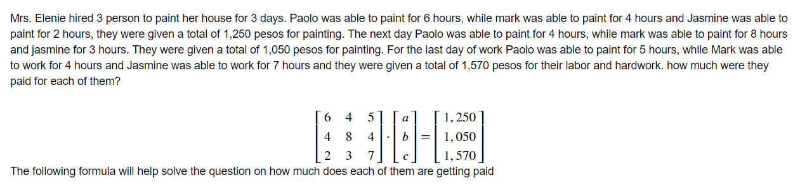

Figure 1: Given problem

As for figure number 1, it shows the problem given by the program to fulfill the given activity, it somehow has a similar way like the example given by the professor. The programmer remembered not being able to solve this kind of problem during his high school days. Given the situation, it is great to solve the same problem but with a different approach.

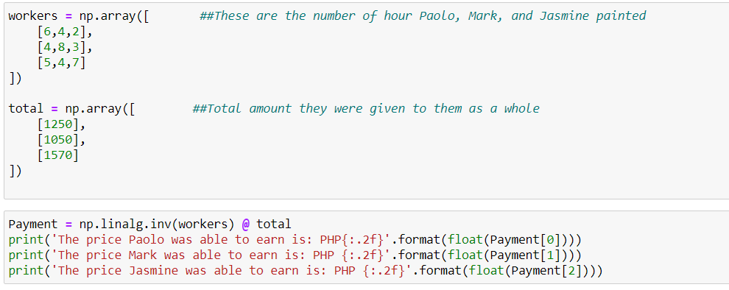

Figure 2: codes used for the 1st task

Similar to the previous activity, this task also uses different matrix and assigning the function on the “Payment” and using the code np.linalg.inv and the @ sign to multiply the given vectors.

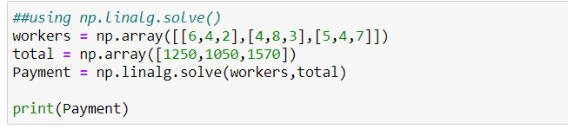

Figure : Using the alternative

As seen on the figure 3, a different version was used which is the np.linalg.solve() which works the same as an alternative, the results were the same. The way the codes are written are somehow different but it is the same it is way simple

# Results

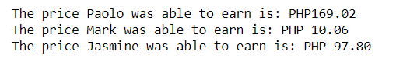

Figure 4: Results for the inverse

As seen from figure 4, these are the results from the program of np.linalg.inv.

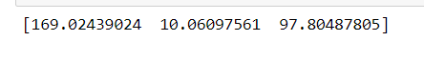

Figure 5: Results of solve

Upon figure 5, np.linalg.solve() there is a small difference in using the inverse and the solve, in using the solve the answers are specific whereas as seen from the figure above there are a lot of decimal numbers from the answer but it is still the same in using the inverse.

# Conclusion

Having the system of linear equations and being able to solve complex mathematical equations is a huge help especially to the programmers, solving and wasting countless numbers of hours for just one number can now be done in an instant. When it comes to the application in robotics, since we are also using matrix here, these can plot the movements of the robots, as well as solving mathematical equations when given. This can also be used for camera matrix which can be used for the vision of the robots. There are a lot of applications of linear equations for robotics.

**Github Repository:**

<https://github.com/ReyesCarl/LinAlg-Lab8>

**References**

[1] D.J.D. Lopez. “Adamson University Computer Engineering Department Honor Code,” AdU-CpE Departmental Policies, 2020.